**Sensor Station Assembly Guide**

**Rev 1.0 – RG – 22nd May 2015**

**Parts**

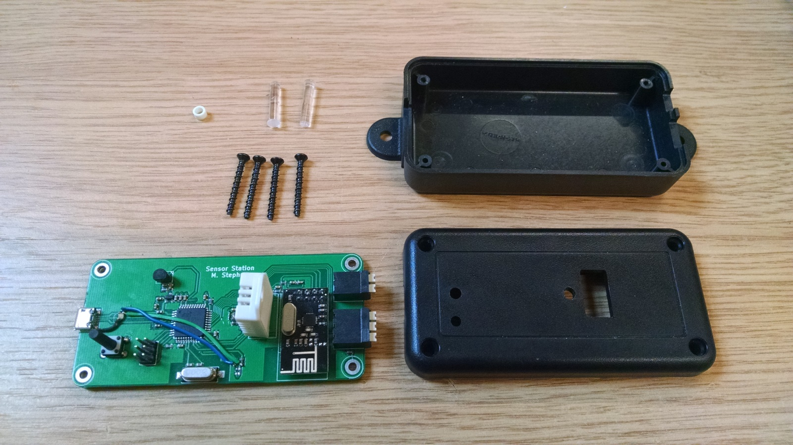

**E**

**D**

**F**

**C**

**A**

**B**

**A – 1x Spacer 3mm Nylon M3 (BOM item 25).**

**B – 2x Light pipes (Bom item 22)**

**C – 4x Screws 4x5/8 Black thread forming (BOM item 24) – Customer supplied.**

**D – 1x Enclosure base (BOM item 23) – Customer supplied.**

**E – 1x Enclosure lid (BOM item 23) – Customer supplied.**

**F – 1x Assembled PCB (old revision pictured, no flying leads on final revision).**

**Step 1 –** Place assembled PCB **F** into enclosure base **D**.

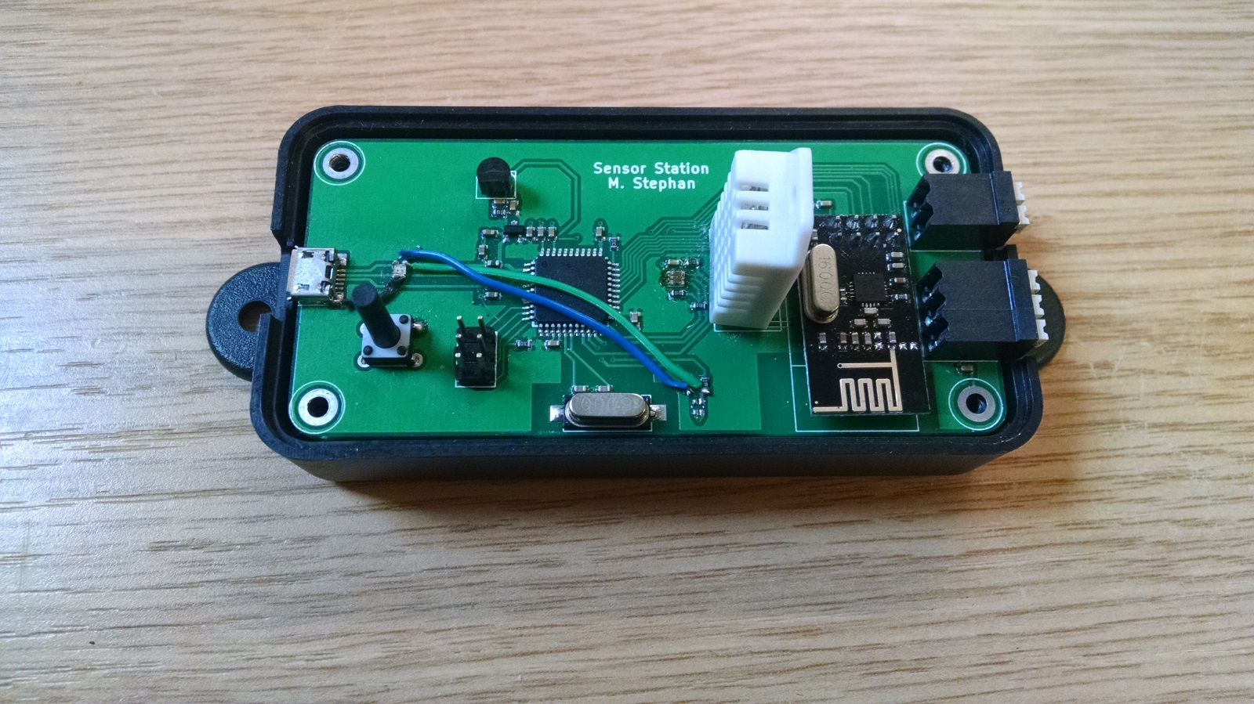

**Step 2 –** Place light pipes **B** into enclosure lid **E**.

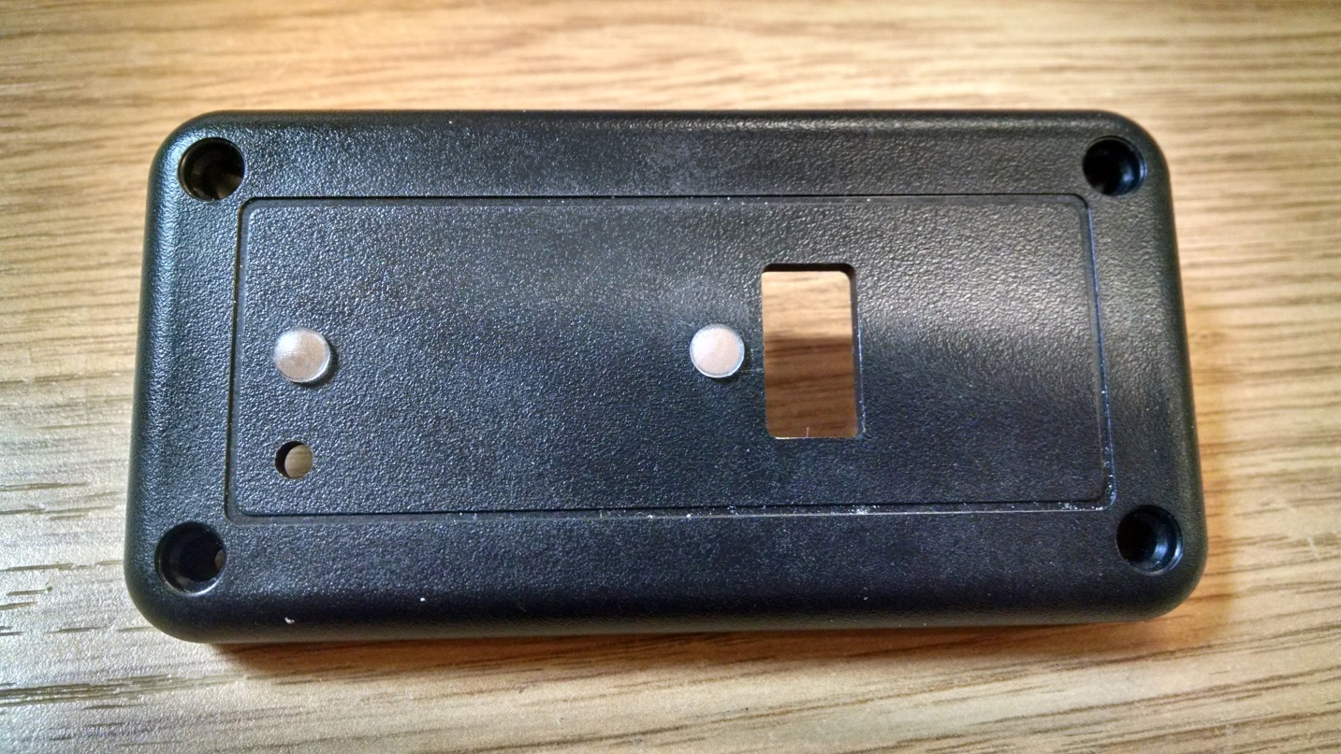

**Step 3 –** Insert one screw **C** into enclosure lid **E** as shown pictured. Then place spacer **A** on to screw as shown pictured.

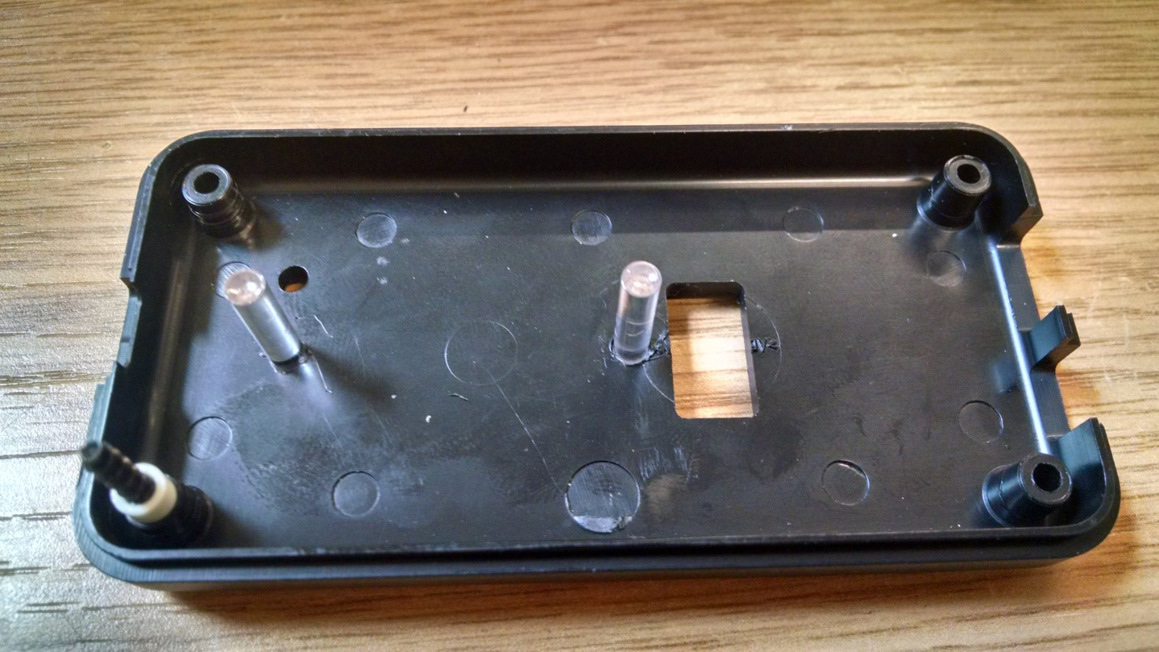

**Step 4 –** Place enclosure lid **E** on to screw holes in enclosure base **D** as shown pictured.

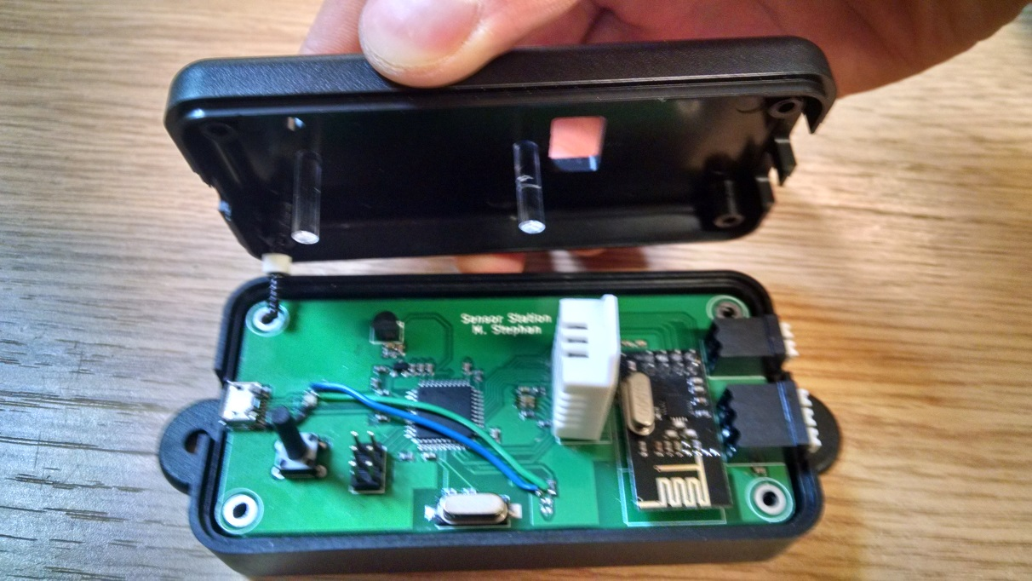

**Step 5 –** Place the three remaining screws **C** in to screw holes in enclosure lid **E**.

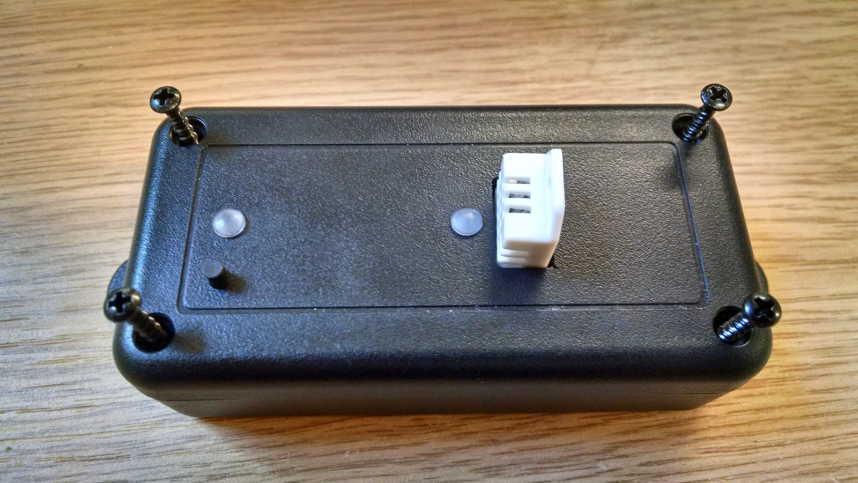

**Step 6 –** Screw down all four screws **C** until tight. Enclosure manufacturer recommends 4 lbs.in torque.

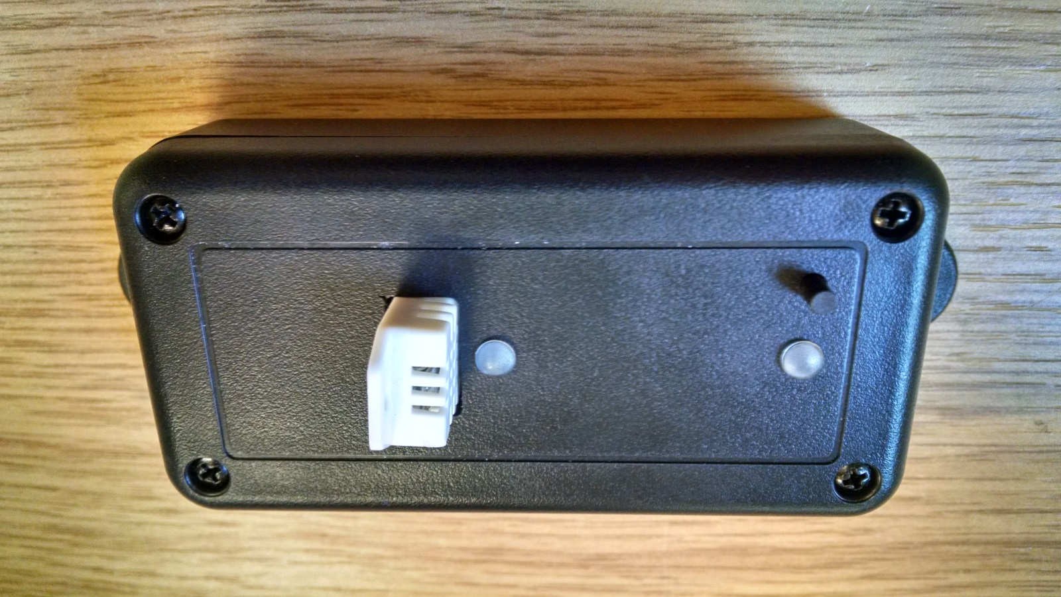

**Assembly complete.**